Assignment 7 ETL Package by Joshua Troup

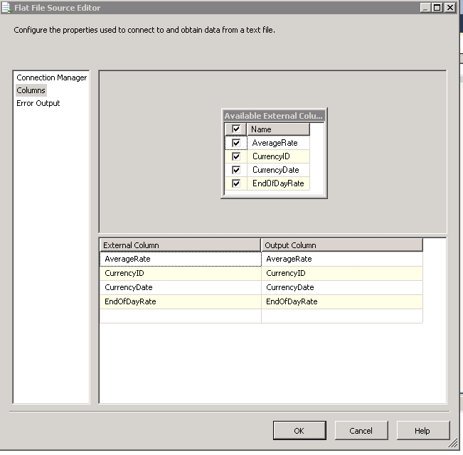

Creation of Flat File Source

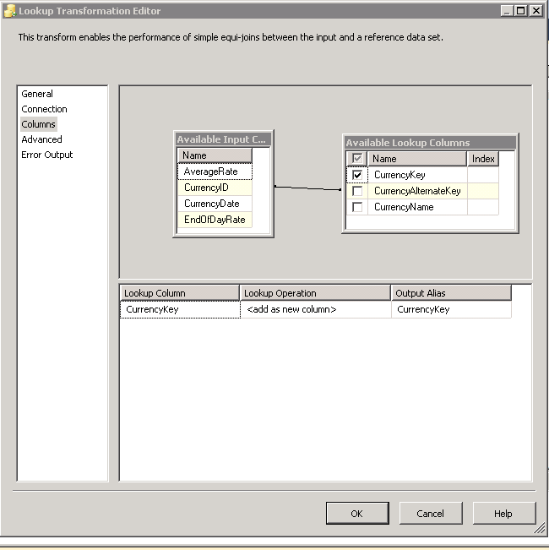

Creation of first Look Up as Currency ID has been dragged to CurrencyAlternateKey. CurrencyKey has been checked.

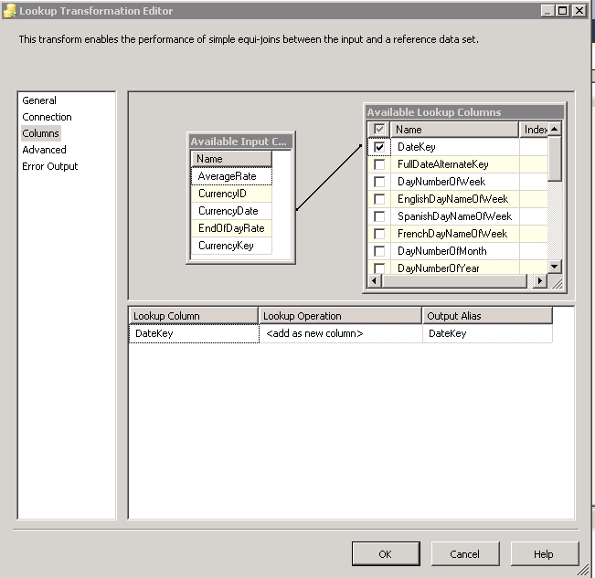

Creation of 2nd Look Up with CurrencyDate connected to DateKey. DateKey has been checked. (Data type was set to Four byte signed integer(DT_I4) as this was the format of the DateKey in the Available Lookup Column.

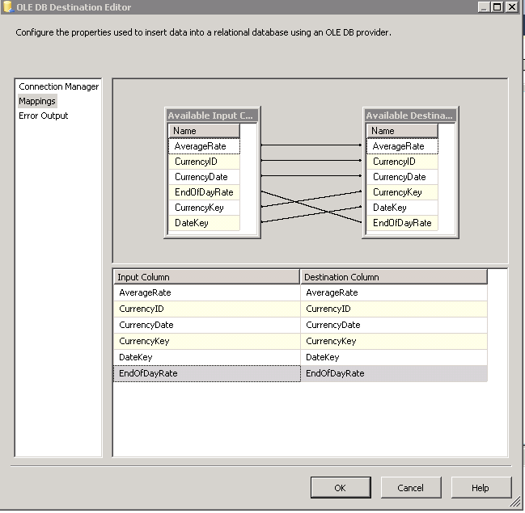

Creation of Destination as the input columns match up with the destination columns.

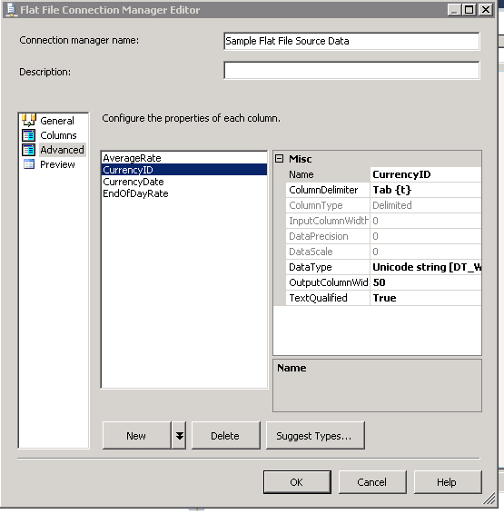

Flat File Connection Manager changing the data types in the column properties. CurrencyID was changed to DT_WSTR. The program recognized the data and allowed me to connect CurrencyID to CurrencyAlternateKey successfully. CurrencyDate was changed to DT_DBDATE. The program did not recognize the data type and did not allow me to connect CurrencyDate to DateKey. I changed data type to Four byte signed integer (DT_I4) as it is the data type of DateKey in the Available Lookup Column.

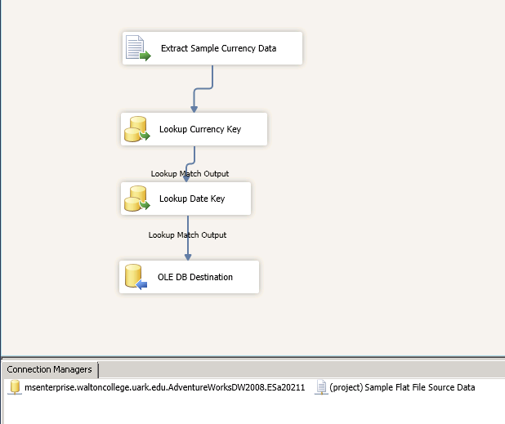

The finished mapping of the ETL with the DateKey data type set to Four byte signed integer (DT_I4). (The only change made to the instructed tutorial. DT_DBDATE would not pair with four byte signed integer (DT_I4) resulting in red X’s not allowing to begin debugging process as CurrencyDate and DateKey were not connected to eachother.

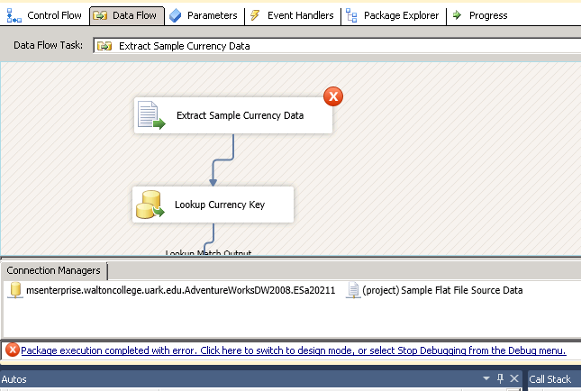

The outcome of debugging the ETL was unsuccessful after several attempts of creating from beginning.